Metropolitan Emergency Managers Association
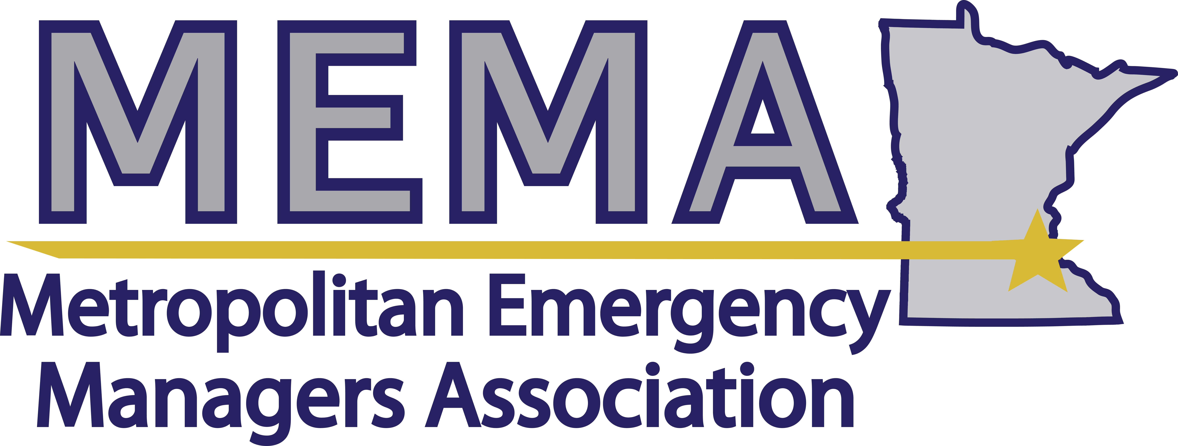
www.mema-mn.com | mema.mn.us@gmail.com

MEETING: GENERAL MEMBERSHIP
Date: November 6, 2019 | Time: 10:00am-12:00pm |  | Location: Target Corporation  1000 Nicollet Mall, Mpls. – 2nd floor
Chairperson: Angela Eastman, President | Secretary: Sean Young-Stephens
Attendees:

MEETING AGENDA
Topic | Discussion and Agreements
Convening | Pledge of Allegiance  (The Pledge will only be said when there is a flag in the room)
Introductions | Board Members  General Membership  Guests
Approval of the minutes | Motion/Second to approve the notes from October
Board report | President  Secretary  Treasurer
Liaison reports | AMEM  Capitol Complex  Emergency Medical Services  Federal Executive Board  Fire  GIS  HSEM  Law Enforcement  Metropolitan Airports Commission  Metro Health and Medical Coalition  Military – Air Force  Military - Army  MNVOAD  National Weather Service  Private Sector partners  Public Health  Public works  University of Minnesota
EM Director Updates  EM Director Updates | Anoka County  Carver County  City of Minneapolis  City of St. Paul  Dakota County  Hennepin County  Isanti County  Ramsey County  Scott County  Washington County
Roundtable | All meeting attendees who have not provided a report are invited to share news, upcoming events, or other information that may be of interest to the group.
Presentation | Presentation and Tour - Target Corporate Command Center Team
Next meeting | Wednesday, December 4 – Cybersecurity presentation from Chris Gabbard and Tony Enriquez from the Cybersecurity and Infrastructure Agency at Bloomington Fire Station #1

